TASK – 05
Titanic Dataset - Exploratory Data Analysis (EDA)
TOPICS:
✅Step 1: Load the Dataset
✅ Step 2: Understand the Data
✅ Step 3: Univariate Analysis
✅ Step 4: Bivariate Analysis
✅ Step 5: Outlier Detection
✅ Step 6: Multivariate Analysis
✅ Step 7: Key Insights & Summary

- Load the Dataset:
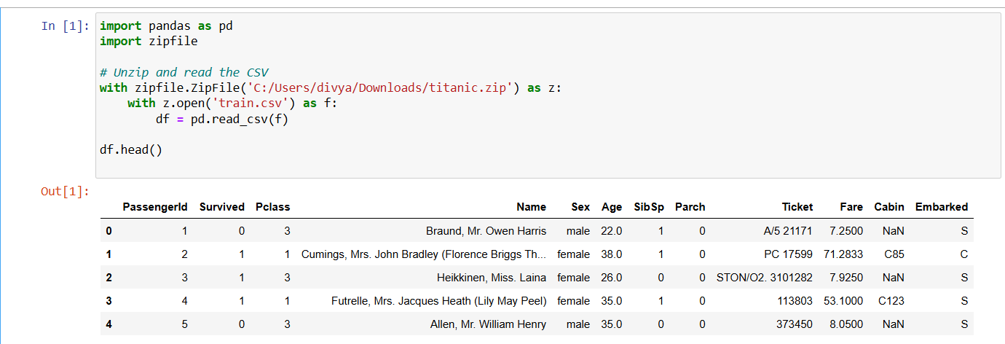

💡 Interpretation:
- Loaded the Titanic dataset into a Pandas DataFrame for analysis.

- Basic Information:
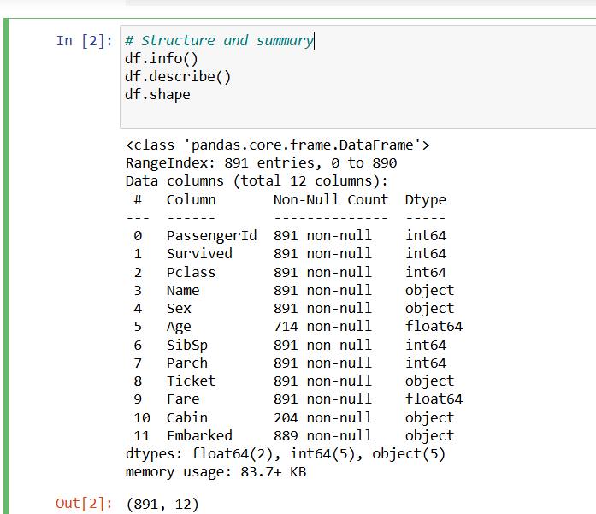

💡 Interpretation:
- Reviewed data structure, types, and summary statistics to get an initial overview.

- Check Missing Values:
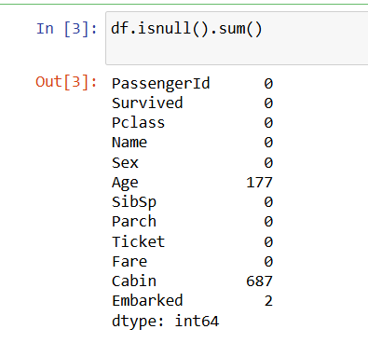

💡 Interpretation:
- Identified columns with missing values to decide how to handle them during data cleaning.

- Univariate Analysis:
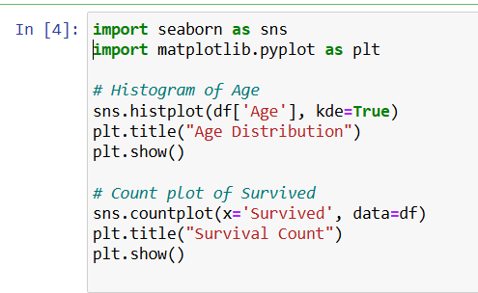
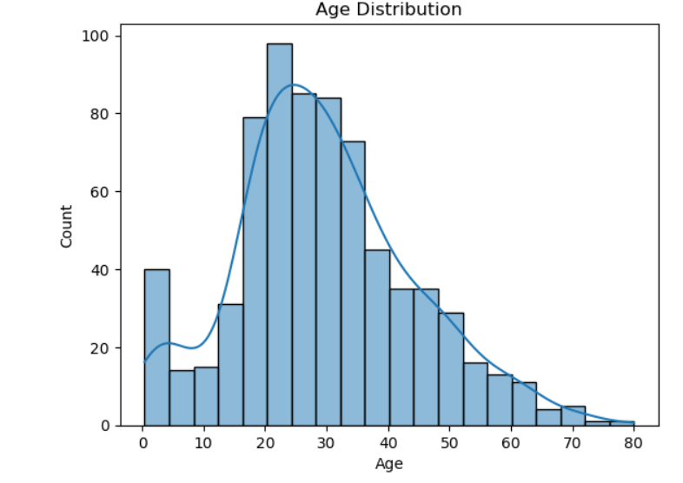
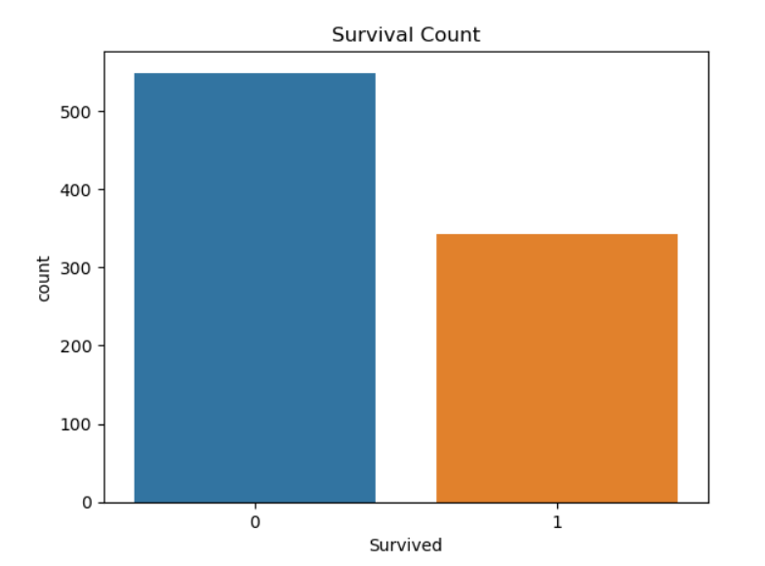

💡 Interpretation:
- Explored individual feature distributions to understand variable behavior.
- Bivariate Analysis:
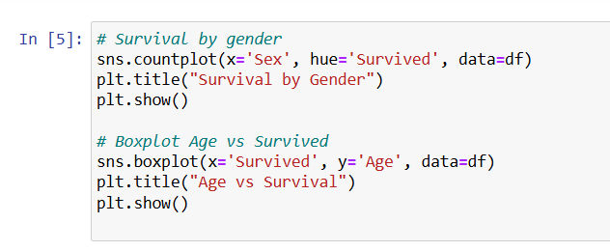
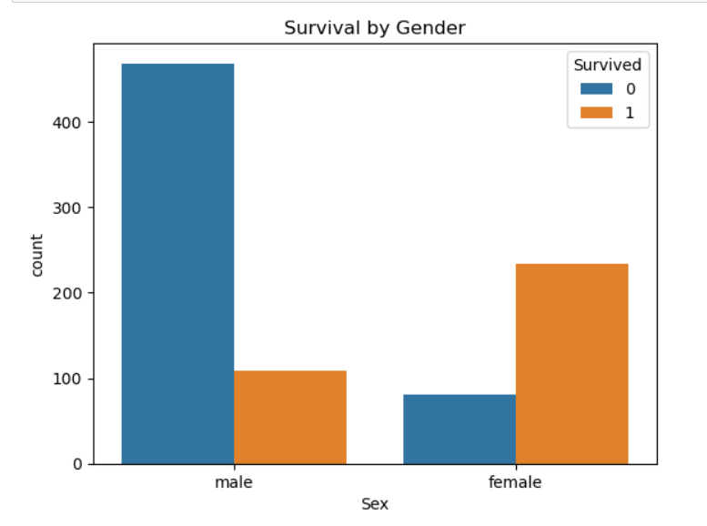

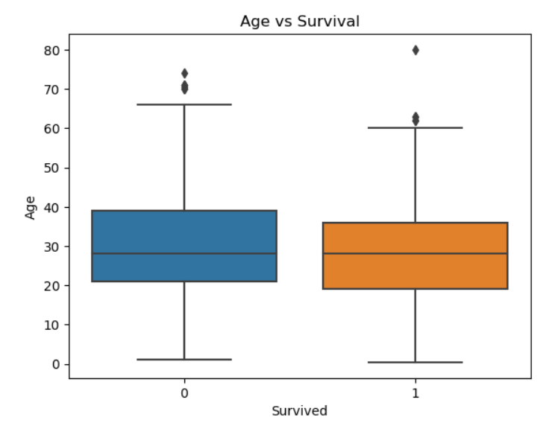

💡 Interpretation:
- Analyzed relationships between target and predictor variables using plots.

- Multivariate Analysis:
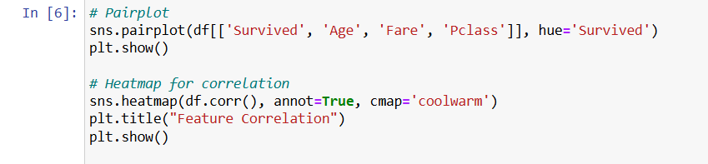
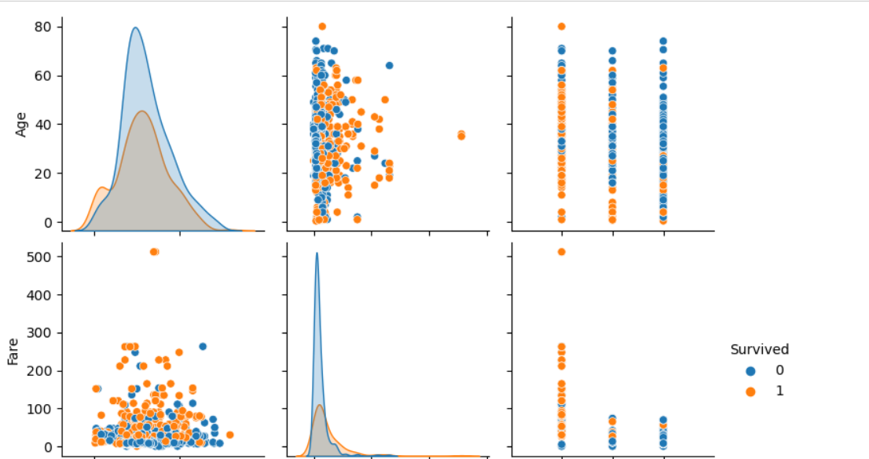
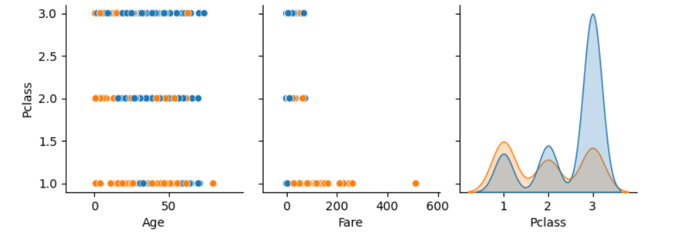
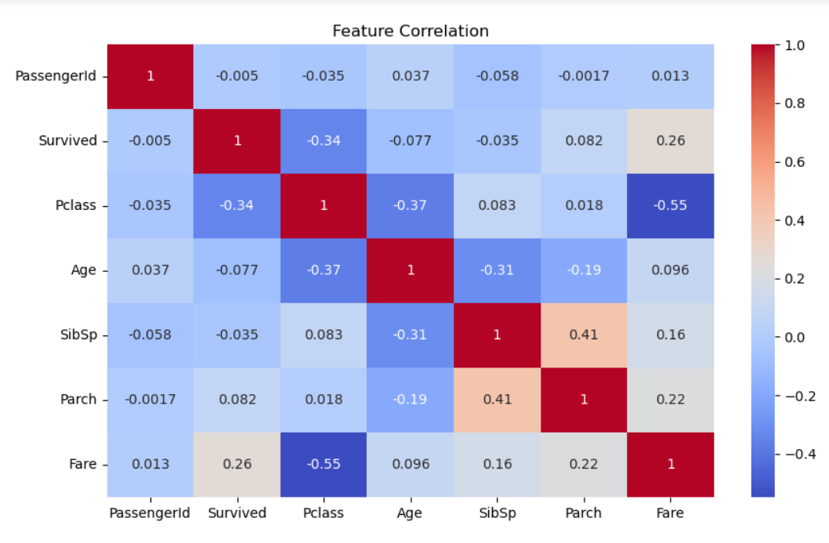

💡 Interpretation:
- Examined interactions and correlations between multiple features.

📌 Insights & Summary
After performing Exploratory Data Analysis (EDA) on the Titanic dataset, here are the key insights:

🎯 Univariate Analysis
- Most passengers were in 3rd class, indicating more budget travelers.
- Majority of passengers were male, and males had a lower survival rate.
- Age distribution shows that most passengers were young adults, with fewer children and elderly.
- Fare was right-skewed, with some passengers paying very high amounts.

🧩 Bivariate Analysis
- Survival rate was higher for females and 1st class passengers.
- Younger passengers had a slightly higher chance of survival.
- Fare paid correlates positively with survival – those who paid more were more likely to survive.

🔗 Multivariate Analysis
- Pairplot revealed a relationship between Pclass, Fare, and Survived.
- Heatmap showed that Pclass, Fare, and Sex (encoded) had the most impact on survival.
- 'Cabin' feature was dropped due to excessive missing values.

🧼 Data Cleaning Done
- Missing values handled (Age, Embarked, Cabin).
- Duplicates checked and removed (if any).
- Irrelevant columns dropped.

💡 Conclusion
The likelihood of survival was significantly influenced by gender, passenger class, and fare paid. Women and first-class passengers had the highest survival rates, making social and economic factors critical during the disaster.

